### **Term Project: Advanced Database Concepts (COMP214) - Fitness club**

**Names**: Deksan Said, Ovovwero Unuavwodo, David Diei and Yerassyl Beregenov  
**Due Date**: Week 12  
**Presentation**: Week 13 (during class)  
**Weight**: 15% of final grade

#### **Project Overview**

This term project is designed to help you apply comprehensive database concepts and techniques to a practical problem. You will develop a database backend and a frontend application for a project of your choice, using Oracle Database. You are expected to work in groups (maximum of 4 people) and demonstrate your knowledge in key areas such as database design, PL/SQL programming, triggers, procedures, functions, sequences, and indexes.

## **2. Problem Domain**

The Fitness Club Database system is designed to manage the operations of a fitness club. The system tracks various aspects of the fitness club, including:

* **Member Management**: Stores personal information of club members, such as names, emails, and membership status.
* **Class Management**: Tracks available fitness classes and their schedules.
* **Staff Management**: Keeps track of staff roles and their responsibilities.
* **Payment Tracking**: Monitors payments made by members for memberships and classes.

The database facilitates smooth operations within the fitness club by providing organized storage and efficient retrieval of member, class, payment, staff and schedule data.

## **3. ER Diagram**

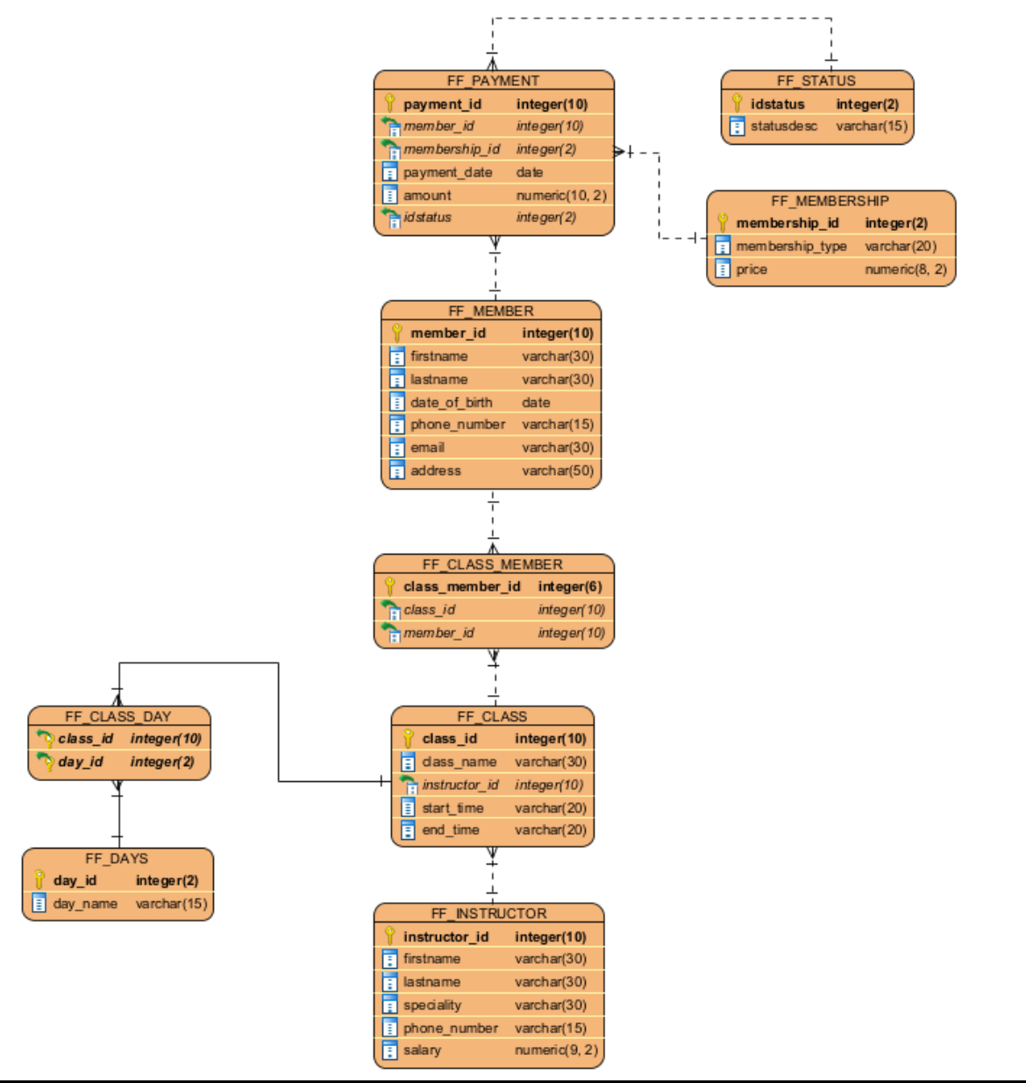

## **4. Screenshots of Front-End Application**

